
Business Question and Visualization Report

Date | 25 October 2026
Team ID | Individual
Project Name | EV Market Analysis
Maximum Marks | 5 Marks

Visualization development refers to the process of creating graphical representations of data to facilitate understanding, analysis, and decision-making. The goal is to transform complex datasets into visual formats that are easy to interpret, enabling users to gain insights and make informed decisions. Visualization development involves selecting appropriate visual elements, designing layouts, and using interactive features to enhance the user experience. This process is commonly associated with data visualization tools and platforms, and it plays a crucial role in business intelligence, analytics, and reporting
Business Questions and Visualisation
The process involves defining specific business questions to guide the creation of meaningful and actionable visualizations in Tableau. Well-framed questions help in identifying key metrics, selecting relevant data, and building visualisation that provide insights.
- Which vehicle categories contribute the most to annual sales?
  - Visualization: Bar chart showing annual sales units by vehicle category (Annual Sales By Category).
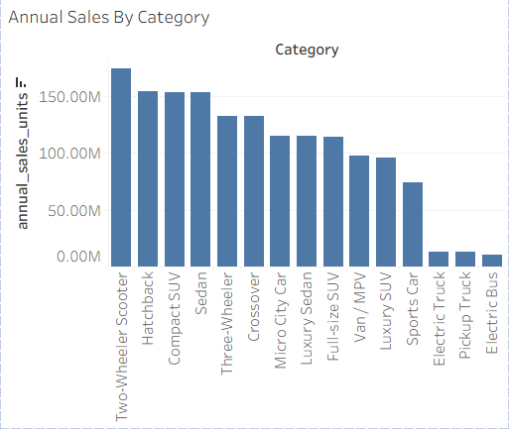
- Which battery technologies dominate the EV market?
  - Visualization: Treemap of battery technology adoption and pie chart of battery technology distribution (NMC, LFP, NCA, Sodium-Ion, Solid-State).
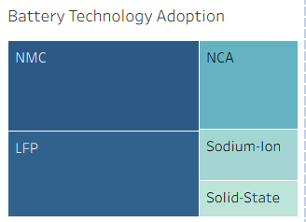
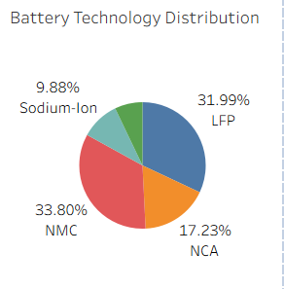
- How does driving range change over model years for each battery technology?
  - Visualization: Heatmap of average range by battery technology and model year (Range Over Time).
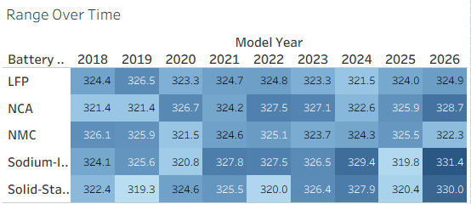
- Which vehicle categories offer the highest driving range?
  - Visualization: Highlight table of average range by vehicle category (Average Range By Vehicle Category).
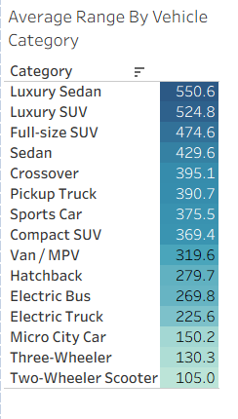
- How does customer satisfaction vary across vehicle categories?
  - Visualization: Dot plot showing average customer rating by vehicle category (Customer Rating by Category).
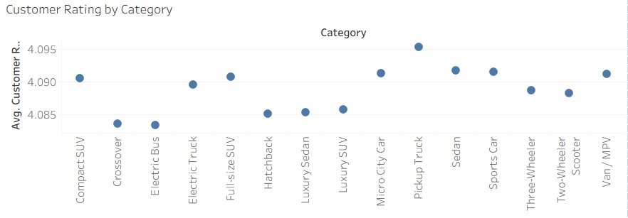
- Who are the top 10 manufacturers by sales?
  - Visualization: Horizontal bar chart of the top 10 manufacturers by annual sales units (Top 10 Manufacturers By Sales).
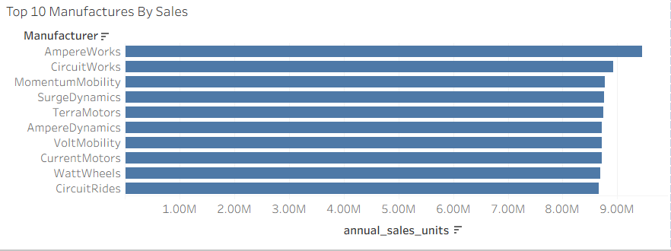
- What is the market share of the leading manufacturers?
  - Visualization: Bar chart showing the market share percentage of the top 10 manufacturers (Manufacturer Market Share Top 10).
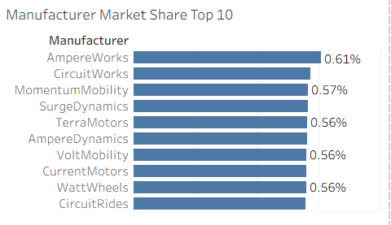
- Which vehicle categories show the highest sales growth over the years?
  - Visualization: Line chart showing % difference in sales by model year for the top 5 growth categories (Top 5 Sales Growth by Year).
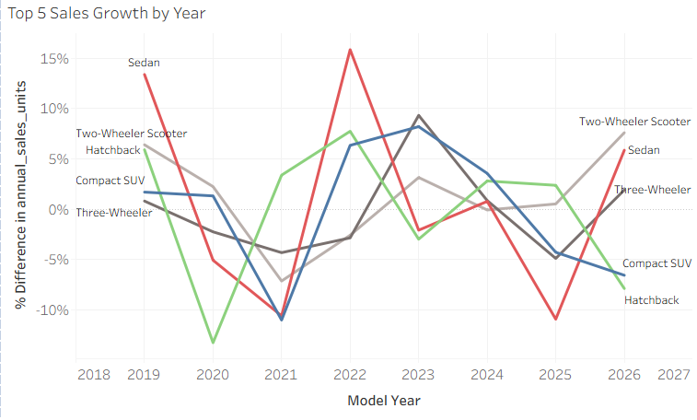
- Which countries have the highest manufacturing sales?
  - Visualization: Filled map showing total sales by manufacturing country (Sales by Manufacturing Country).
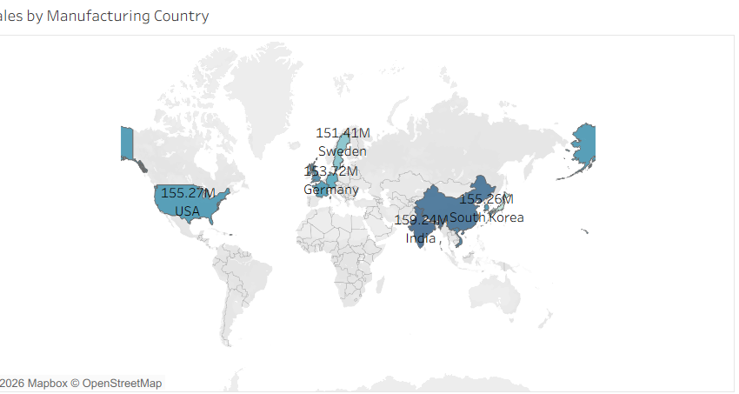
- Is there a relationship between customer rating and sales for manufacturers?
  - Visualization: Scatter plot of total sales against average customer rating by manufacturer, with average reference lines (Rating vs Sales by Manufacturer).
